

SUPRA SAEINDIA 2024
IMPACT ATTENUATOR DATA (IAD) REPORT



Team Number: 35

Team Name : Velocity Vikings

College Name : PDPM IIITDM Jabalpur

City : Jabalpur, Madhya Pradesh

Report Author : Ajay Meena

Report Co-Author : Aashish Kothawade

1. Report Details:
I. Technical specifications :
• Material & shape of IA : IMPAXX 700 Energy Absorbing Foam & Frustum of a Pyramid.
• Construction details of IA : IMPAXX foam is a highly engineered, extruded, thermoplastic foam that utilizes Dow proprietary process technology to maximize efficiency and minimize weight, making it a strong, low density , closed-cell foam.
• Dimension of IA (Length, Breadth, Height) : 356*305*255 mm
• Height and width at a distance 200 mm forward of bulkhead : 168.14*237.57 mm
• Material of Anti Intrusion Plate : 6061 T6 Aluminum
• Thickness of AIP : 6 mm
• Attachment method of AIP with front bulkhead : Bolt
• Number of bolts used, diameter of each bolt, Grade of bolt : 4 bolts, Diameter – 8 mm, Grade 8.8
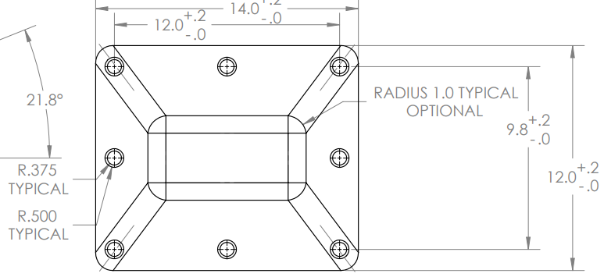
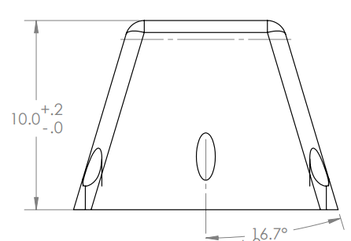
• Drawing of Impact Attenuator with dimensions :

II.Photographs required:
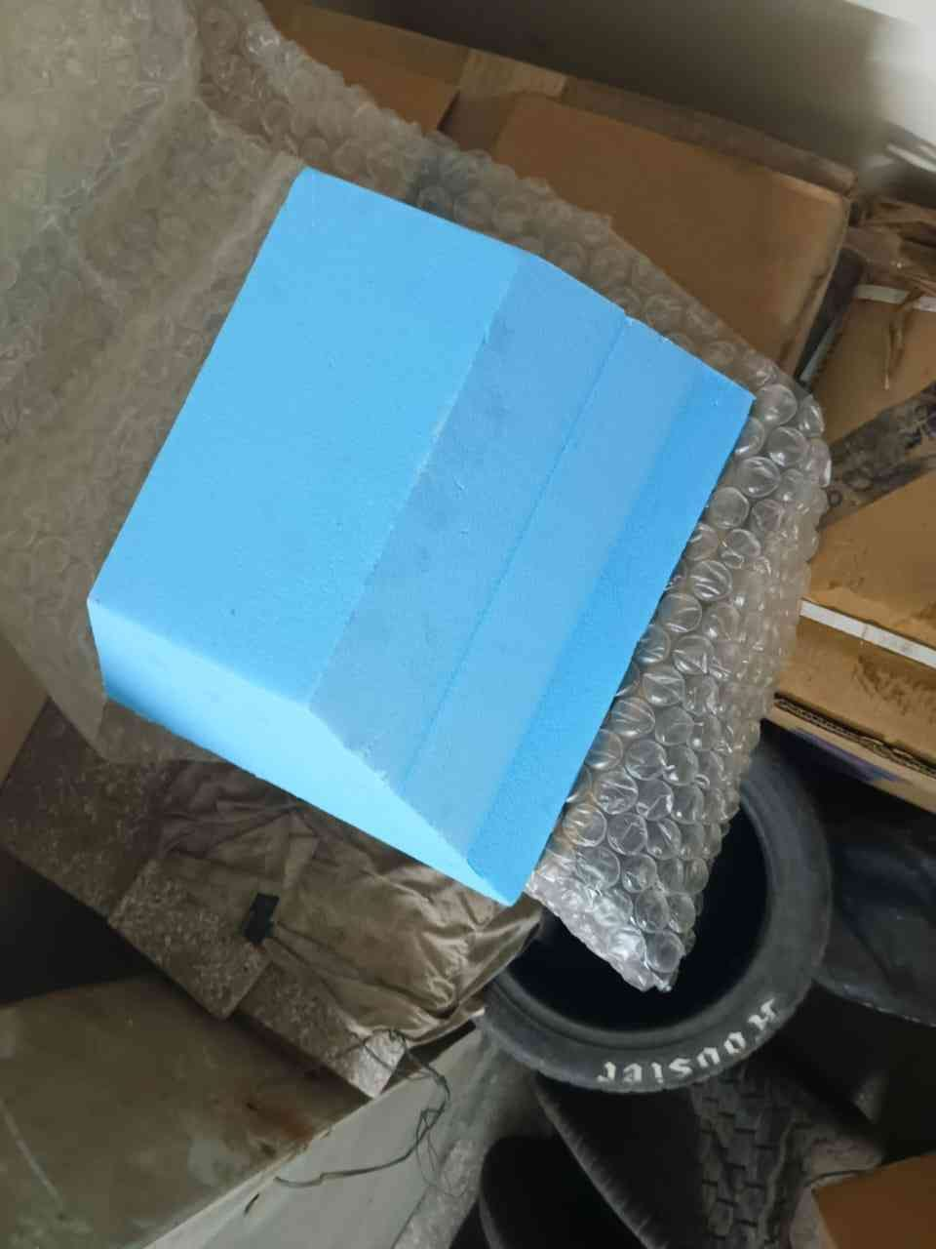
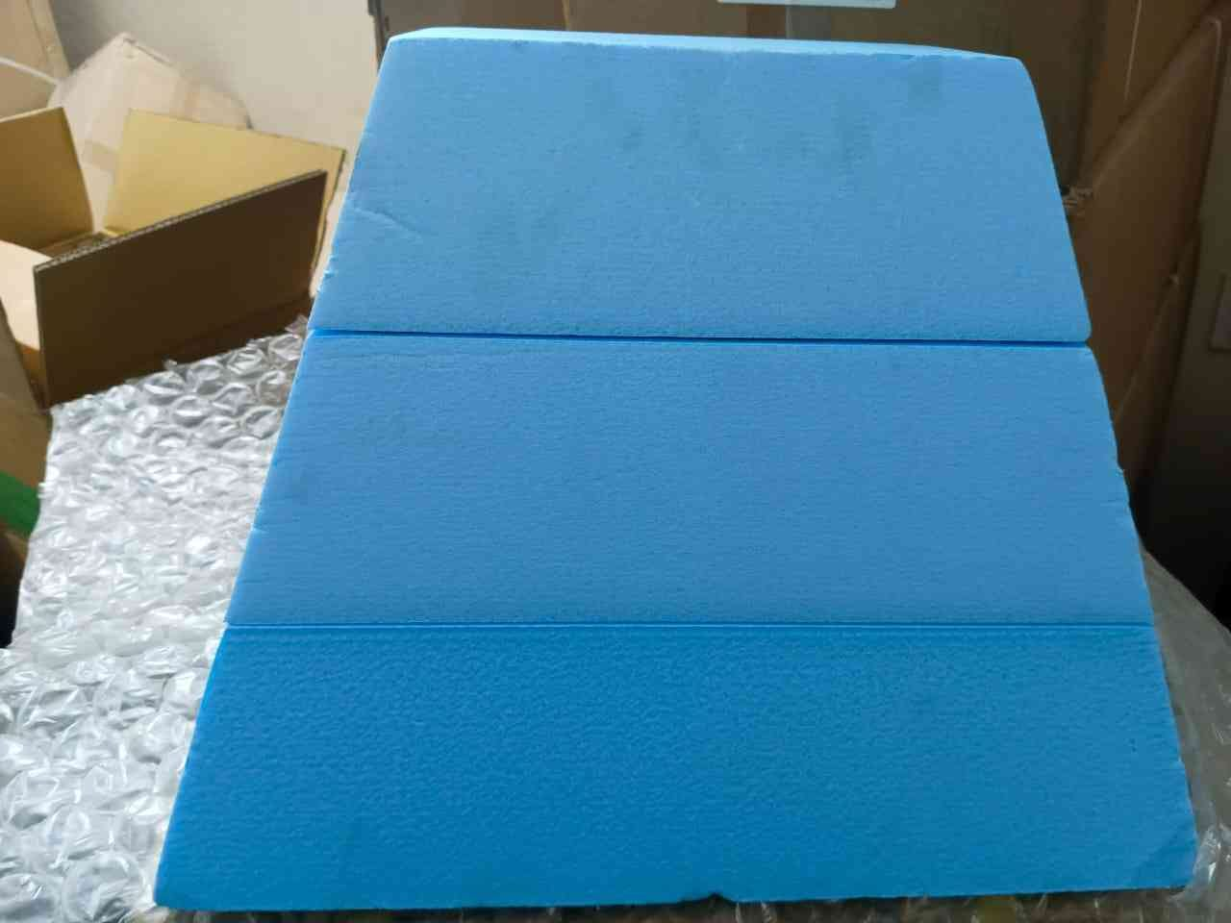
a) Dimensions of IA showing measurement of actual IA with scale:

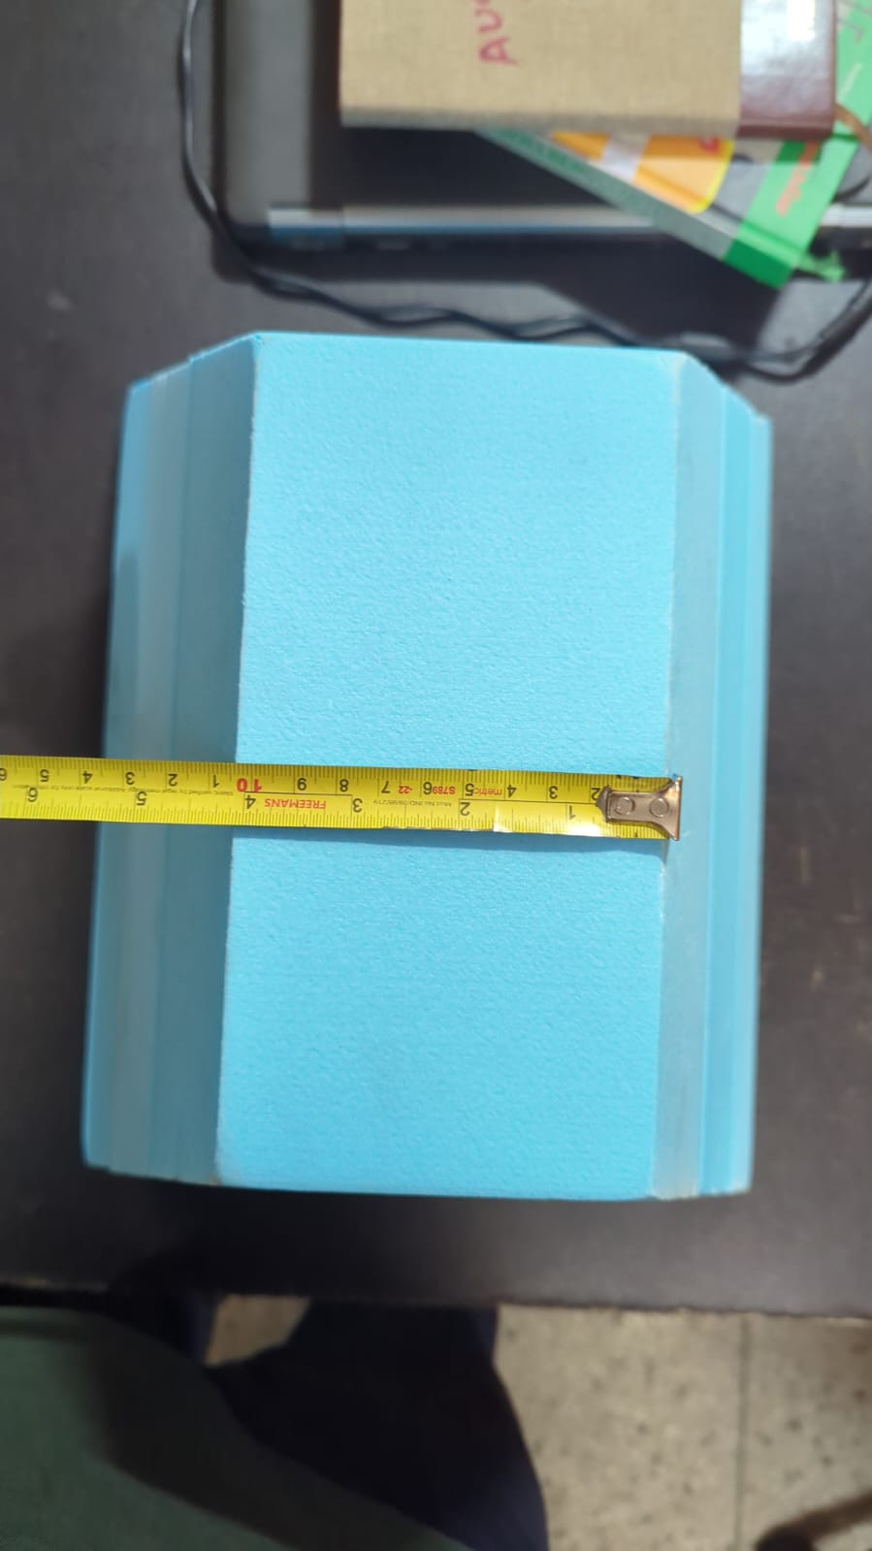
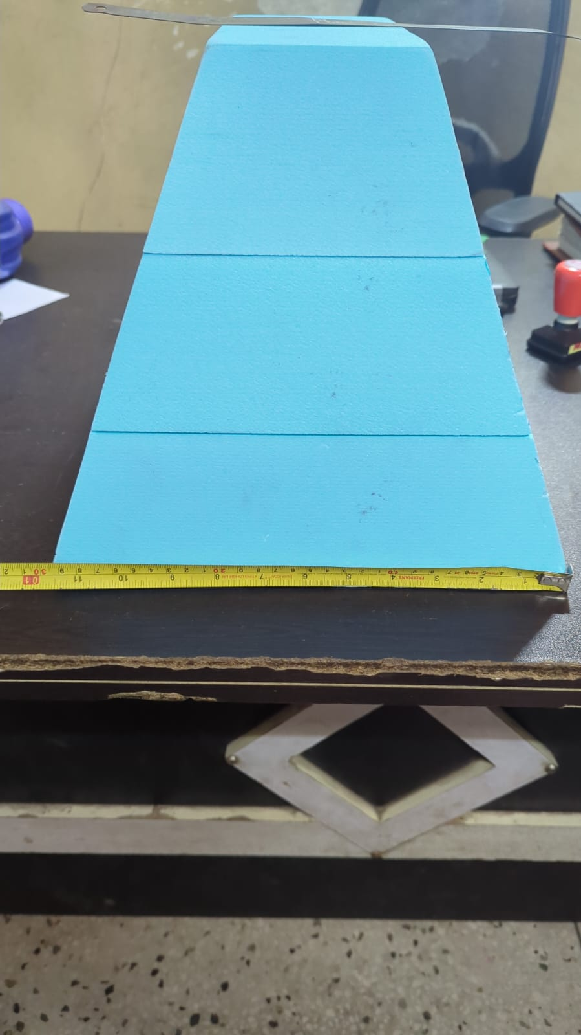

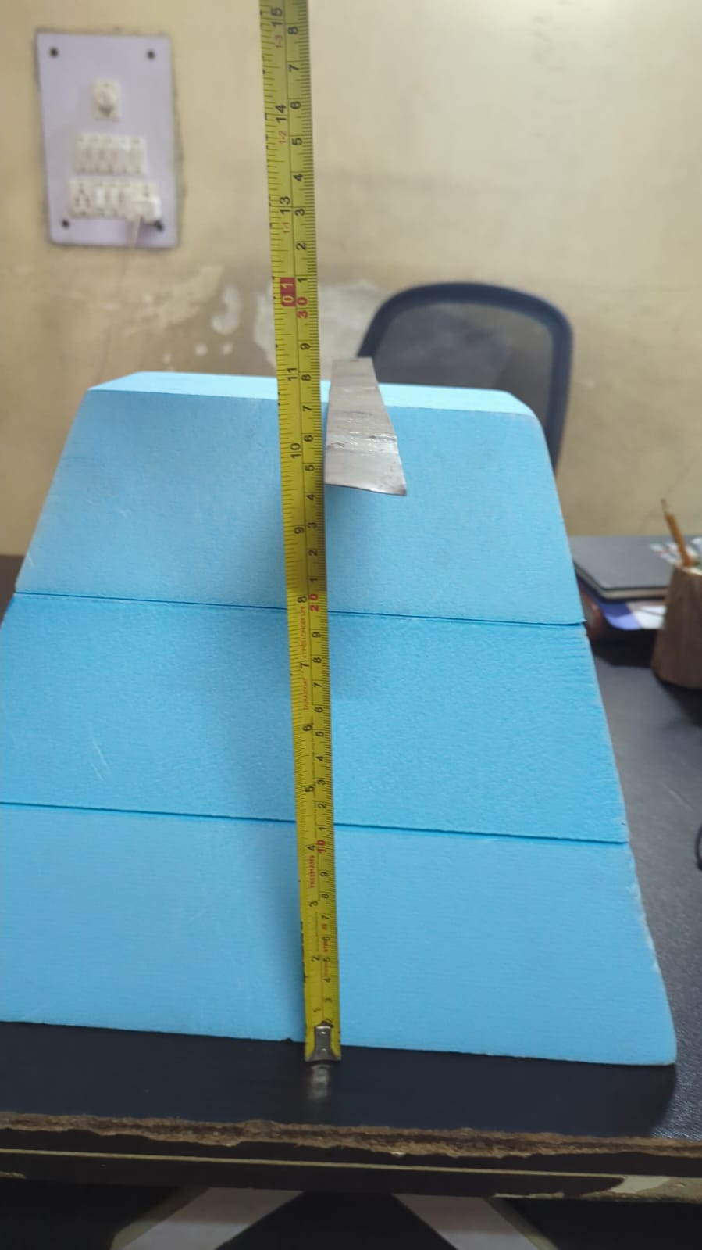

b) Tax invoice of the IA:
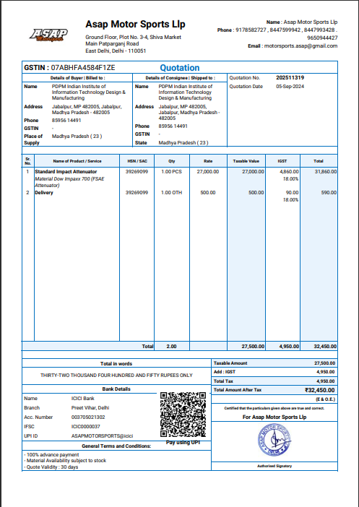

c) Picture of IA attached to the vehicle:
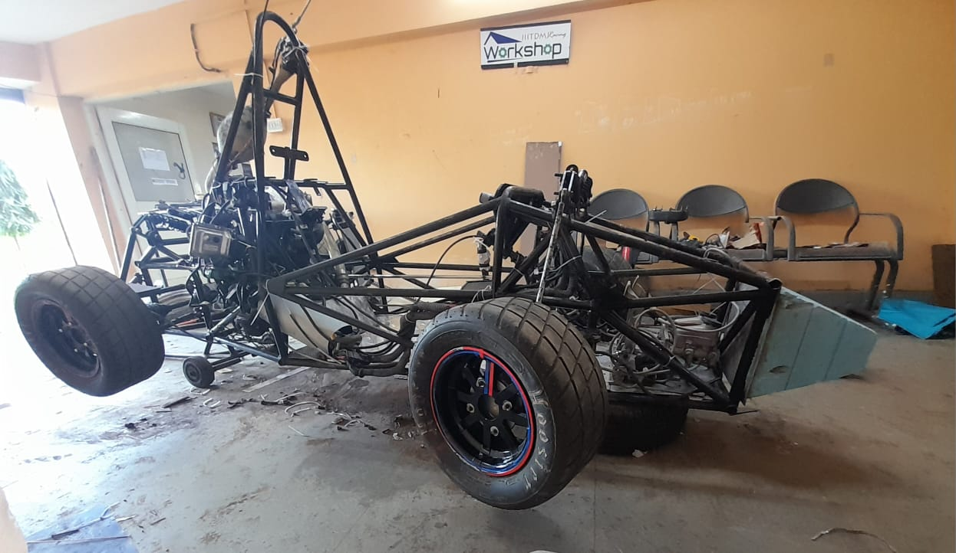
2.Conclusion:
Since it is a standard impact attenuator, it has been already tested by the manufacturer and it satisfies the given conditions:
• Average value of deceleration is not greater than 20g.
• Maximum deceleration value is not greater than 40g.
• Maximum deflection of AIP is not higher than 25.4 mm.

